Mental Health Update December 23
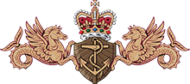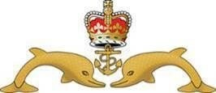
Welcome to the Monthly Mental Health Update
- What is the Mental Health Update? It is your monthly digest of upcoming mental health awareness dates for your diary. It also contains information about the mental health topic(s) of that particular month and guides you through the signs, symptoms, support and resources linked to that topic.
- Why do we have it? Talking openly about mental health can reduce the misconceptions and stigma. It can encourage those who are struggling to seek help and find a support network. It's important for clinicians, the divisional team, colleagues and friends to understand the impact that mental health has on our day-day lives.
- Who produces it? Royal Navy Mental Health Nurses from SURFLOT (East and West), SUBFLOT and UK Commando Forces.

This Month’s Topics:
- Mental Fitness during Winter Months
- Use of Vitamin D supplements
- Mental Fitness during Christmas
- Drink aware!

Mental Fitness during the Winter months
During December we celebrate the Winter Solstice. The winter solstice, also called the hibernal solstice, occurs when either of Earth's poles reaches its maximum tilt away from the Sun. The winter solstice is the shortest day of the year and marks the start of winter in the Northern Hemisphere.
Sunlight can affect some of the brain’s chemicals and hormones. One theory is that light stimulates a part of the brain called the hypothalamus which controls mood, appetite and sleep. These things can affect how you feel.
A lack of sunlight and a problem with certain brain chemicals stops the hypothalamus working properly. The lack of light is thought to affect:
- the production of the hormone melatonin
- the production of the hormone serotonin
- the body’s circadian rhythm (the body’s internal clock, which regulates several biological processes during a 24-hour period)
When these things are disrupted, it can lead us to feel low in mood. It can also lead to other symptoms such as: loss of interest in activities we normally enjoy, feeling irritable, tearfulness ,feeling stressed or anxious, a reduced sex drive, be less active than normal, feel tired and sleep more than normal (hypersomnia), feel lethargic (lack energy), find it difficult to concentrate, have an increased appetite and eat more than usual (hyperphagia).

How Can We Battle the Winter Blues?
Take Care of Yourself
Sometimes, it may feel impossible to get up, shower and start your day, but it needs to be done. By pushing yourself to take care of yourself, you’ll instantly feel better. Even if you get nothing else done that day, knowing that you’ve accomplished something will make things easier.

Be Active
Taking part in regular physical activity has been shown to improve mental health and well-being. Whether you choose to go to the gym or take a slow walk, it doesn’t matter as the intensity of your workout doesn’t need to be tough for it to make a difference. Get active for mental wellbeing

Get A Hobby
Spending time unproductively has a large impact on poor mental health. By taking up a hobby, you can focus your spare time on working on something you enjoy rather than getting stuck in a rut. Popular hobbies include exercising, reading, learning new languages and creating artwork.

Step Out of Your Comfort Zone
When you have the same routine each day, the repetition can be mentally draining rather than stimulating. To keep the brain active and improve awareness, try switching things up by visiting new places, taking new routes and organising you’re living or working area. Spending time in a tidy space helps you to de-clutter your mind too. Learning new skills can give you a sense of achievement and a new confidence. So why not sign up for that cooking course, start learning to play a musical instrument, or figure out how to fix your bike? Find out more in Learn for mental wellbeing

Maintain Relationships
If you’re feeling a little under the weather, it’s common to push people away and spend time alone. Making a conscious effort to have a phone call, head out for a coffee or just have a quick chat with friends or family will remind you that you’re not alone. Social relationships are essential for improved mental health. Learn more in Connect for mental wellbeing

Give to Others
Even the smallest act can count, whether it’s a smile, a thank you or a kind word. Larger acts, such as volunteering at your local community centre, can improve your mental wellbeing and help you build new social networks. Learn more in Give for mental wellbeing. International Volunteer Day is on December 5 annually, why not take this opportunity to give to others.

Be Mindful
Be more aware of the present moment, including your thoughts and feelings, your body and the world around you. Some people call this awareness “mindfulness”. It can positively change the way you feel about life and how you approach challenges. Learn more in Mindfulness for mental wellbeing. You can practice mindfulness for free by downloading the Headspace app - See below for more details.

Do Good December
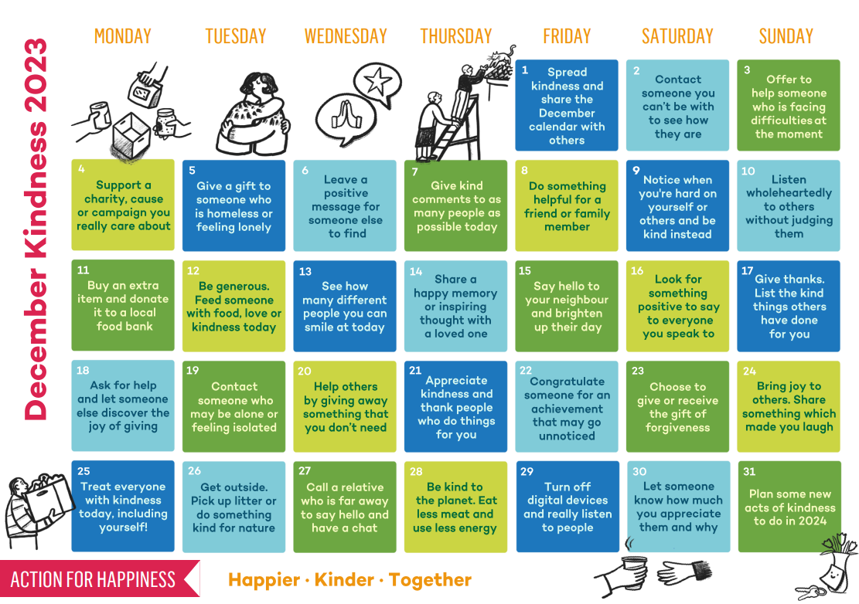

Vitamin D
Vitamin D – ‘the sun vitamin’ – is one of 13 ‘essential vitamins’. Essential vitamins are those which are vital for your body to function properly. Usually, Vitamin D3 is produced in your skin when this is exposed to sunlight – UVB radiation.
Vitamin D deficiency is more common in the winter when the days are shorter and darker.
Vitamin D deficiency affects all age groups, races and different ethnic backgrounds.
Between October and early March, we do not make enough vitamin D from sunlight.
Vitamin D is also found in a small number of foods.
Sources include:
- oily fish – such as salmon, sardines, herring and mackerel
- red meat
- liver
- egg yolks
- fortified foods – such as some fat spreads and breakfast cereals
- In the UK, cows' milk is generally not a good source of vitamin D because it is not fortified, as it is in some other countries.
Another source of vitamin D is dietary supplements, through a process called hydroxylation the liver and kidneys turn vitamin D supplements into the active form the body needs. There is no difference between sun-light vitamin D, food sourced vitamin D or supplement vitamin D.
Everyone should consider taking a daily supplement containing 10 micrograms of vitamin D during the autumn and winter.
As with any supplement make sure it is sourced from an approved supplier, speak with your MO/GP/Medical team for further information, especially if you have any known medical conditions.

Mental Fitness at Christmas
Looking after yourself
- Be gentle and patient with yourself. It might help to think about what is best for your wellbeing during Christmas and prioritise what you need.
- Remind yourself that it won't last forever. You could set a 'start' and 'finish' time for what you count as Christmas.
- Set your boundaries. Try to say no to things that aren't helpful for you.
- Let yourself experience your own feelings. Even if they don't match what's going on around you, they're still valid. For example, if you don't feel like celebrating Christmas when everyone else does.
- Take time out. Do something to forget that it's Christmas or distract yourself. For example, you could watch a film or read a book that's set in the summer. Or you could try learning a new skill.
- Let yourself have the things you need. For example, if you need to take a break instead of doing an activity or need a little bit of quiet time.
Coping with money worries
It can be tough to cope with the financial pressures of Christmas. This can be especially difficult if you're already struggling with money. And for many of us, rises in the cost of living will have made things even harder.
How you cope with the costs of Christmas will depend on your circumstances. You might not find all of these tips realistic. But it may help to try some of them:
- Make lists, plans or a budget. Noting things down can make them feel a bit more manageable or help you think more clearly. Creating a budget could also help you feel more in control of what you can spend. See our page on organising your finances for more tips. You could also use Money Helper's free online budget planner.
- Be open with others. It can be hard to talk about money. But being honest with others can help. You may be able to agree ways to make Christmas plans free or low cost. Or they might be able to offer other kinds of support. Step Change's festive support has information on talking to other people about money worries.
- Look for local offers or events. Local organisations, such as charities and community centres, may have free or low-cost events for Christmas. Or they may be able to offer support with things like gifts or food.
- Look for free or low-cost items online. You may be able to find free items to use as gifts or decorations online, for example through websites like Freecycle.
- Try to avoid comparisons with the Christmas you see in adverts and social media. These often do not reflect reality and can make us feel bad about ourselves. It may help to take breaks from social media.
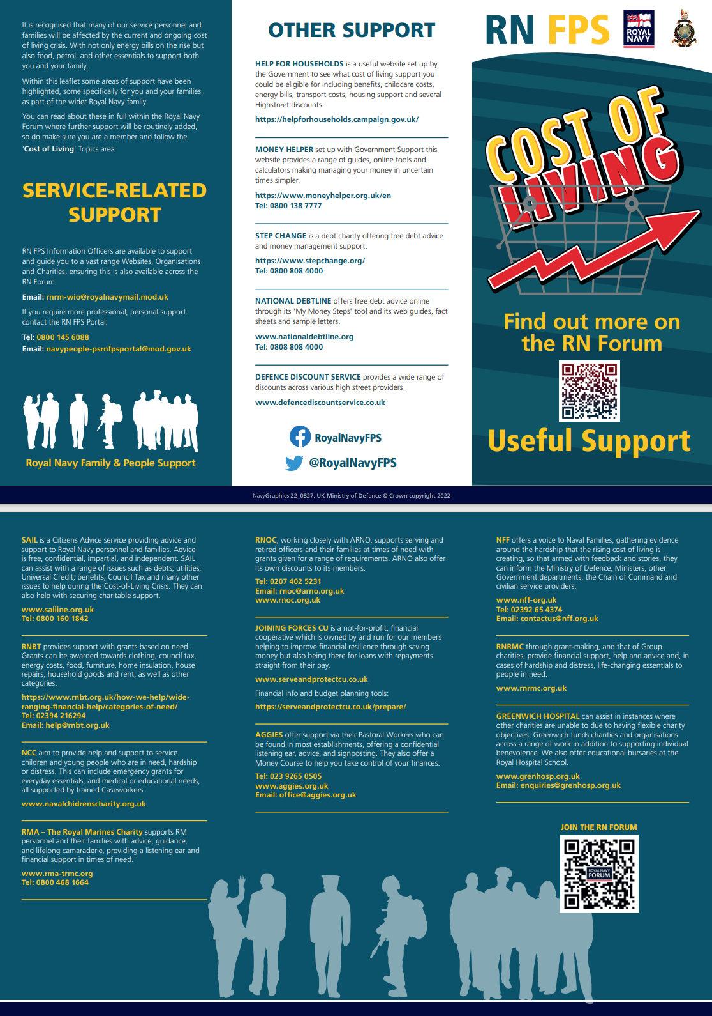
- Be kind to yourself. Money worries can have a big impact on our mental health. They might make us feel concerned, embarrassed or angry. And they can affect our self-esteem. Try not to blame yourself for your situation or how you're feeling about it.

Planning ahead
Think about what might be difficult about Christmas for you, and if there's anything that may help you cope. It might help to write this down. For example:
- If you're going to be somewhere unfamiliar for Christmas, think about what you need to help you cope. Are there things you can bring to make you feel more comfortable? Or is there somewhere you can go to take a break?
- If having a routine is important to you, try to include as much of your regular routine in your Christmas plans as you can. This could help prevent you feeling too disrupted. Or you could slowly introduce Christmas activities to your routine, rather than do them all at once.
- If you sometimes experience flashbacks, panic attacks or dissociation, make a note of what helps during these moments, and keep it with you.
- Certain places may feel very uncomfortable for you, for example if they bring back difficult memories. If possible, you could plan to spend less time in difficult places, or not go at all.
- Think about whether you really need to do things if you're not looking forward to them. It may that you can do them for less time, or in a different way.
- Make a list of any services that you might need and their Christmas opening hours. Our page of useful contacts lists some organisations who can help.
- Pharmacies can be closed on certain days over the Christmas period. So, if you take medication, make sure you have enough for the whole period.
- If you're worried about feeling lonely or isolated this Christmas, think of some ways to help pass the time. For example, this might be doing something creative or spending time in nature. See our pages on relaxation for more ideas.
- If you're in hospital or a care home, see what activities might be running over Christmas that you might want to take part in.
- If you can't be with the people you want to see in person, you could arrange a phone or video call to catch up with them on Christmas day. Or try to arrange a visit around Christmas, if there's a time when it's possible to meet.
- Try out some new traditions if any of your previous traditions don't feel possible this year. For example, if they're too expensive, or too difficult because of a bereavement. These new ideas could be a one-off, or they could become part of Christmas in future.
- Try to plan something nice to do after Christmas. Having something to look forward to next year could make a real difference.
Managing relationships
- If other people's questions are difficult, you could try to think of some answers in advance. For example, about your plans or how you're doing.
- Think about how to end difficult conversations. It's ok to tell someone you don't want to talk about something, or to change the subject. It might help to practise what you'll say.
- Suggest an activity or an easy way to move on, if you want to help end an unwanted conversation. For example, this could be playing a game, or taking a screen break if you're on a video call.
- Talk about your plans in advance. It might help to agree on things such as budgets or timings beforehand. For example, you could agree not to give presents this year, or decide a set amount to spend.
- If other people don't seem to understand how you're feeling, you could share this information with them. You could also think about writing down how you're feeling and sharing this with them, if conversations are difficult.
- It's ok if there are people you don't want to see at Christmas. If you can't avoid spending time with them, try to think of ways to keep a distance while you're there.
Talking to other people
- Let people know you're struggling. It can help to talk to someone you trust about how you're feeling. See our page on opening up to others about your mental health for tips.
- You could join an online community to talk others who have similar experiences to yours. Mind's online community Side by Side is a safe place to connect with others who understand what you're going through.
- Tell people what they can do to help. And let them know if there's anything they could avoid doing. For example, let them know any activities you'd like to be involved in, and how they can support you during Christmas. Or you could tell them any topics you find hard to discuss, so they can avoid asking.
- You don't have to justify yourself to others. But you might feel pressure to, especially if someone asks a lot of questions. It could help to let them know that certain situations are difficult for you and tell them what they can do to help. It might also help to tell them that you understand they may see things in a different way.
- You might not be able to make others understand. But try to remember it's not your responsibility to convince other people or get their permission to look after yourself.
Christmas coping tips - Mind
Drink Aware
Christmas is around the corner and who doesn’t love a Christmas party and a mince pie, or two, or three? But this is a time when many people find themselves drinking more than they usually do.
Drinkaware Home | Drinkaware
If you choose to drink alcohol this Christmas:
1. Keep in mind the Chief Medical Officers’ low risk drinking guidelines and try not to drink more than 14 units, which is six standard glasses of 13% wine or six pints of 4% beer, in any week
2. If you choose to drink this much, then spread the drinking over three or more days and avoid binge drinking. Drinkaware’s app is there to help people track and calculate their units so that they can see their progress over time. Visit: Drinkaware Track and Calculate Units App
3. Try allocating several days every week when you don’t drink – the drink free days. This will help to reduce the overall amount of alcohol that you drink and let family and friends know that you are not always drinking and that it's perfectly normal not to do so. If you have children, it will also show them that Christmas doesn't have to include alcohol. Find out more at Drink Free Days
4. Don’t drink on an empty stomach. A healthy meal before you go out or start drinking, and snacks between drinks can help to slow down the absorption of alcohol, helping you stay in control.
5. Avoid drinking before you go out, what some people call ‘preloading’– it’s very easy for the drinks to stack up that way
6. Pace yourself by alternating any alcoholic drinks with water or soft drinks and avoid drinking in rounds, which may make you drink more and faster than you intended
7. Try downsizing your alcoholic drinks– it will help you to drink less and reduce the number of calories that you are taking on board
8. Try having a no or low alcohol alternative or an alcohol-free mocktail – they are just as tasty
9. If you’re heading out to a Christmas party, make your plans in advance on how you will get home, with a licensed taxi cab, and with people that you trust. Remember that lone men can be vulnerable too.
10. Keep warm and always take a coat. Alcohol makes blood flow to the blood vessels near your skin and away from the core of your body. If you then go out in the cold after drinking, you can lose heat very easily and quickly. And that can be dangerous.
11. Remember that drinking and driving kills. It’s best to avoid alcohol completely if you are driving, even if that’s the morning after
12. And looking ahead to 2024: The New Year is a fantastic opportunity for people to really look at the amount of alcohol they drink and, where necessary, to make long lasting changes to their drinking that can benefit their health and well-being. Drinkaware has a wide range of tools and apps to help.
Looking to the New Year....

Let’s Get Active – For Women event, a new initiative to focus on Health, Wellness and Sport at all levels for Service Women. The challenges and barriers affecting women taking part in various health related activities are well documented through Sport England, such as:
· There are 313,600 fewer women than men who are regularly active
· More men do sport and physical activity than women at almost every age group
· When asked, 13 million women said they'd like to do more sport and physical activity
· 4 in 10 women are not active enough to ensure they get the full health benefits.

To enhance understanding on these topics a ‘Lets Get Active’ initiative will take place at HMS Temeraire on Wed 10 Jan 24 from 0900 – 1530For more information: RNTM 10-052/23 LET’S GET ACTIVE – FOR WOMEN

Further Support and Information
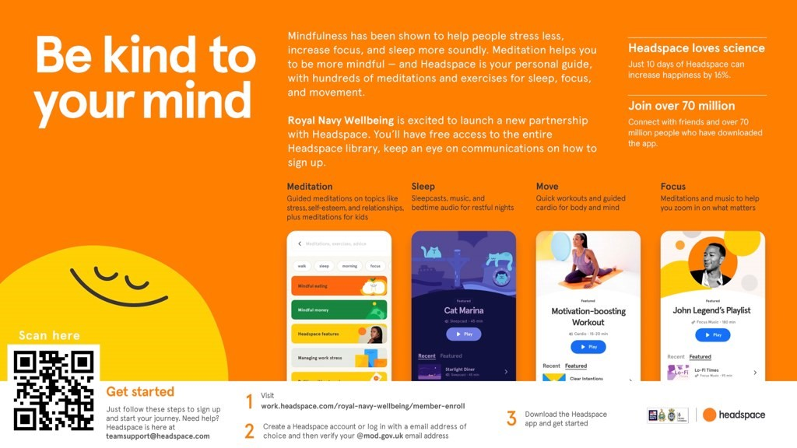

Signposting - because sometimes we need some support to change things.
- Speak with your CoC,
- Royal Navy Family and People Support - Contact on: Phone - 023 9272 8777, Freephone - 0800 145 6088
- https://www.royalnavy.mod.uk/community-and-support/advice-and-support
- Padre
- MO/GP
- DCMH - self-refer through REGAIN, REBALANCE by calling 01206 817057 and tell them you wish to refer yourself.
Support
- Samaritans - Provide confidential, non-judgemental, emotional support 24/7 for people experiencing feelings of distress call 116 123
- Combat Stress - Provide a 24-hour mental health helpline for serving personnel and their families call 0800 323 4444
- Togetherall (formally Big White Wall) An online community for people who are stressed, anxious or feeling low. Round the clock support from trained professionals - https://togetherall.com/en-gb/big-white-wall
- Head Space is a mindfulness app with dedicated video’s, exercises to improve mental fitness, reduce stress and relaxation techniques visit https://work.headspace.com/royal-navy-wellbeing/member-enroll.
- HeadFIT- HeadFIT for Life helps defence people stay mentally fit and on top of their game… At work and at home visit https://headfit.org/
Free Counselling
- Relate - Free relationship counselling. Utilising relate does not mean your relationship is on the rocks, it means your being proactive to protect your relationship and make it stronger to continue to prioritise your relationship despite your career demanding you to deploy. Relate can also be used if you are single to look at your More info can be found here - https://www.relate.org.uk/centre/dorset-and-south-wiltshire/services/support-armed-forces
- Cruse Bereavement Care - Cruse is a charity for bereaved people which offers support, advice and information when someone dies. They have face-to-face, freephone, email and website support - https://www.cruse.org.uk/ There is also a website (www.hopeagain.org.uk) specifically for children and young people. All services are provided by trained volunteers and are confidential and free.
Information
- MOD Share Point Health and Wellbeing Portal visit https://modgovuk.sharepoint.com/sites/IntranetHeadOffice/SitePages/Health-And-Wellbeing.aspx
- Royal Navy – Naval Service Health & Wellbeing & RN Executive Health website
- Army – Mental Resilience & OPSMART
- RAF – RAF Health & Wellbeing
- MOD Health and Wellbeing- The MOD Health and Wellbeing site has several links to information, guidance, resources and tools to improve wellbeing and ensure we can continue to do our jobs well visit http://defenceintranet.diif.r.mil.uk/Personnel/HealthandWellbeing/Pages/HealthandWellbeing.aspx
- MIND (Mental Health Charity) Provide advice and support to empower anyone experiencing a mental health problem. Tel: 0300 123 3393 or visit www.mind.org.uk
- Mental Health UK (Mental Health Charity) Useful resources to help you find help and support. - https://mentalhealth-uk.org/help-and-information/health-and-wellbeing
- Living Life To The Full - The Living Life To The Full course is a life skills course that aims to provide access to high quality and user-friendly training in practical approaches you can use in your own life. The course content teaches how to tackle and respond to issues and demands which we all meet in our everyday lives, with techniques specifically aimed at anxiety and depression VISIT https://llttf.com/
- Lifting the Lid: Campaign to raise awareness of mental health issues among the Royal Marines, encourage help seeking behaviours and signposting to existing resources https://rma-trmc.org/wellbeing/mental-health-and-wellbeing/lifting-the-lid/
- Every Mind Matters: www.nhs.uk/every-mind-matters
- MyNavy App
Charities and Family Support - because our families also need support.
- Kooth - A Service for children from serving families. Kooth can act as the first step in assuring children and young people receive the earliest intervention for their wellbeing and mental health concerns and have clear pathways for any additional face to face support and safeguarding- https://www.kooth.com/
- Qwell - Free, safe and anonymous mental wellbeing support for adults across the UK that includes online messaging, booked and drop in chat, community support, personal development tools by accredited counsellors (BACP, UKCP and NCS) VISIT https://www.qwell.io/
- Talkworks - A free, confidential, NHS talking therapy service, part of IAPT (Improving Access to Psychological Therapies), for people (aged 18+) in Devon (excluding Plymouth), helping you to feel better and giving you the tools and techniques to improve your mental and physical wellbeing. Self-help guides and links to approved apps and many MH resources. Mental Health Resources | TALKWORKS (dpt.nhs.uk), Devon Partnership NHS Trust - Self Help Guides (dpt.nhs.uk)
- Royal Navy Children’s Charity – Provide financial and holistic support to help children (up to the age of 25) of Naval families, serving and veterans. Call on 023 9263 9534, email caseworkers@navalchildrenscharity.org.uk or visit https://www.navalchildrenscharity.org.uk/
- Royal Marine Association – Provide educational, employment, health and wellbeing, service transition support, to all RM. Their Lifting The Lid project promotes positive mental health through education and supporting RM’s to access help. Visit: https://rma-trmc.org/
- RN/RM Charity – call 023 9387 1520, email theteam@rnrmc.org.uk or visit https://www.rnrmc.org.uk/
- Building Stronger Families’ - is a free relationship counselling portal for Royal Navy and Royal Marines personnel and their partners. To help with relationships, help with family life and parenting, help with separation and divorce and help for children, young people and young adults. It also includes bereavement and loss support. Visit - https://rnrmc.learnupon.com/users/sign_in?next=%2Fdashboard
- SSAFA - Provide financial, practical and emotional support to those with a service connection. Phone 0800 731 4880 or visit: https://www.ssafa.org.uk/
- Living Life To The Full - The Living Life To The Full course is a life skills course that aims to provide access to high quality and user-friendly training in practical approaches you can use in your own life. The course content teaches how to tackle and respond to issues and demands which we all meet in our everyday lives, with techniques specifically aimed at anxiety and depression VISIT https://llttf.com/
- Naval Families Federation. Provide support, drive change and champion RN, RM serving families as they navigate serving and civilian life challenges. VISIT https://nff.org.uk/

