Mental Health Update January 24
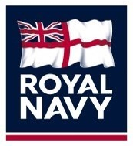

Welcome to the Monthly Mental Health Update

- What is the Mental Health Update? It is your monthly digest of upcoming mental health awareness dates for your diary. It also contains information about the mental health topic(s) of that particular month and guides you through the signs, symptoms, support and resources linked to that topic.
- Why do we have it? Talking openly about mental health can reduce the misconceptions and stigma. It can encourage those who are struggling to seek help and find a support network. It's important for clinicians, the divisional team, colleagues and friends to understand the impact that mental health has on our day-day lives.
- Who produces it? Royal Navy Mental Health Nurses from SURFLOT (East and West), SUBFLOT and UK Commando Forces.

This Month’s Topics:
- Blue Monday – January 15th
- Happier January Calendar
- Further support & information

Blue Monday
Beat the bleak, post-festive slump by setting (or resetting) resolutions, getting some exercise in the fresh air or watching an uplifting movie.
January can be a great month for many different reasons, most of all that a new year has just begun that we can use to fulfil our New Year’s resolutions and achieve any number of other things we’ve decided to put our minds to.
However, a cold, cloudy January can also be quite the comedown after the festive holiday season that preceded it, one that was filled with the very delicious dishes that caused us to gain the weight we’re endeavouring to lose in the first place. So, to be fair: of all the months of the year, January can be considered the bleakest of them all.
History of Blue Monday
- Blue Monday was created back in 2005 by Sky Travel Shop, a television channel devoted exclusively to programs about traveling, documentaries, and commercials for travel agencies
- The people at Sky Travel named this day “Blue Monday” and called it the most depressing day of the year for a variety of reasons
- The date varies from year to year, depending on a variety of factors, such as weather, debt, the time that has passed since Christmas day, the time that has passed since we failed at fulfilling our New Year’s resolutions, low motivational levels connected with previous failures, and the need to take action
- Many say that Blue Monday has particular symptoms, such as feeling down/sluggish and depressed from the colder weather and end of holiday festivities
How to Celebrate Blue Monday
Pseudoscience or not, there is absolutely nothing wrong with taking a look at January with an open mind, and being honest with yourself as to what you could try your best to do better at for the remainder of the year. Failed New Year’s resolutions are very common, so if you have failed at persevering, now would be a great time to think a bit about why that is and how that could have been avoided. Next, you can create a new resolution or two and, wiser now than before, succeed at them this time around.
Think about how you managed your resolutions, and if you didn’t set yourself up for failure right off the bat by creating unrealistic expectations of yourself. Did you decide to go vegan starting January first? Going vegan is a big move, and of course an honourable one, but it is also quite challenging, especially if you were eating steaks and yogurt and sunny-side-up eggs just the day before.
Deciding that you will suddenly cut every single animal product could be much more of a sacrifice than your body is ready to make overnight, and so you may find yourself sliding within a few days, only to feel miserable for failing. So instead of going vegan, perhaps go vegetarian for a while first to help your body get accustomed to your new eating habits.
Then, after a few months, when you feel ready, it will be time to take the next step. In short, take this day to re-plan your resolutions so you can get them right the next time around.
Rather than setting large New Year’s Resolutions, set smaller ones that are easier to achieve. Go vegetarian instead of vegan or cut out one specific animal product. Set smaller exercise goals such as aiming to work out for 30 minutes at least four times a week. Rather than trying to run a marathon, set smaller goals for running a certain amount of miles by a certain date.
Tips to Combat Blue Monday
While some believe that Blue Monday should be celebrated, others believe there is a science behind avoiding the “Blue Monday” blues. Psychologists believe that your Monday mindset controls the outcome of Blue Monday. If the day is sunny, it is recommended to go take a walk and enjoy the sunshine.
You can also go to the gym or do some form of physical exercise. These endorphins will help combat sadness and boost your mood! Even twenty to thirty minutes of activity is enough to cause a noticeable increase in your mood.
If you need something to take your mind off of the winter weather, consider an uplifting movie. Some suggestions are Rocky, Mary Poppins, Bridesmaids, Step Brothers, or any other comedy film you enjoy!
If you’re not a movie person, consider rewatching your favourite television show or reading a chapter of your favourite book. You can also invite friends or family over if you don’t want to spend the day alone. Having the people you love around is sure to boost your spirits!
If you prefer to spend the day alone, try to do some form of self-care. This could be anything from lighting a candle, ordering/ cooking your favourite meal, calling someone you love, or taking a bath. Spend some time on yourself and use this day to refocus the rest of your year!
In conclusion, your mindset controls how your Blue Monday looks! Rather than feeling down on yourself, consider this day as a way to think about how you want the rest of your year to look. Redraft your resolutions, set smaller goals, or even indulge in self-care or have company visit. Make this Monday a day to remember and refocus!
Happier January Calendar
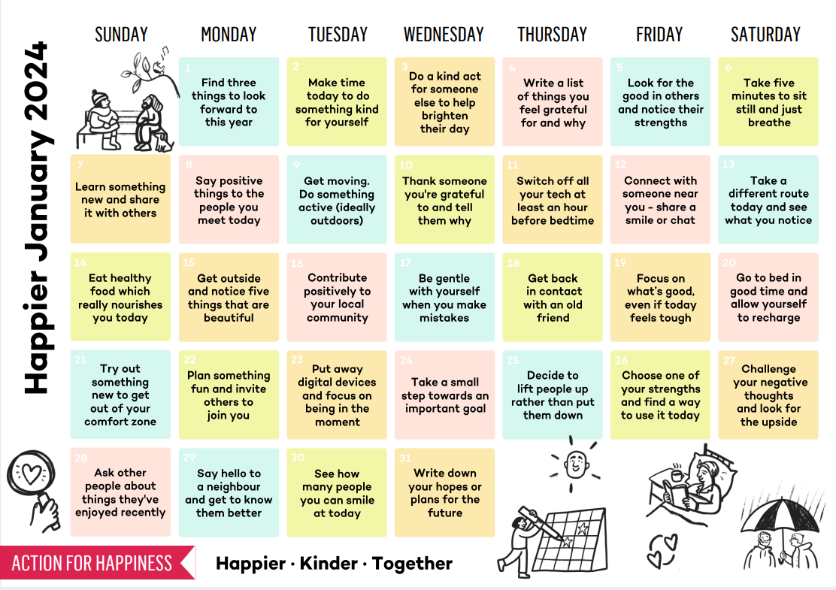

Further Support and Information

Signposting - because sometimes we need some support to change things.
- Speak with your CoC,
- Royal Navy Family and People Support - Contact on: Phone - 023 9272 8777, Freephone - 0800 145 6088
- https://www.royalnavy.mod.uk/community-and-support/advice-and-support
- Padre
- MO/GP
- DCMH - self-refer through REGAIN, REBALANCE by calling 01206 817057 and tell them you wish to refer yourself.

Support
- Samaritans - Provide confidential, non-judgemental, emotional support 24/7 for people experiencing feelings of distress call 116 123
- Combat Stress - Provide a 24-hour mental health helpline for serving personnel and their families call 0800 323 4444
- Togetherall (formally Big White Wall) An online community for people who are stressed, anxious or feeling low. Round the clock support from trained professionals - https://togetherall.com/en-gb/big-white-wall
- Head Space is a mindfulness app with dedicated video’s, exercises to improve mental fitness, reduce stress and relaxation techniques visit https://work.headspace.com/royal-navy-wellbeing/member-enroll.
- HeadFIT- HeadFIT for Life helps defence people stay mentally fit and on top of their game… At work and at home visit https://headfit.org/

Free Counselling
- Relate - Free relationship counselling. Utilising relate does not mean your relationship is on the rocks, it means your being proactive to protect your relationship and make it stronger to continue to prioritise your relationship despite your career demanding you to deploy. Relate can also be used if you are single to look at your More info can be found here - https://www.relate.org.uk/centre/dorset-and-south-wiltshire/services/support-armed-forces
- Cruse Bereavement Care - Cruse is a charity for bereaved people which offers support, advice and information when someone dies. They have face-to-face, freephone, email and website support - https://www.cruse.org.uk/ There is also a website (www.hopeagain.org.uk) specifically for children and young people. All services are provided by trained volunteers and are confidential and free.

Information
- MOD Share Point Health and Wellbeing Portal visit https://modgovuk.sharepoint.com/sites/IntranetHeadOffice/SitePages/Health-And-Wellbeing.aspx
- Royal Navy – Naval Service Health & Wellbeing & RN Executive Health website
- Army – Mental Resilience & OPSMART
- RAF – RAF Health & Wellbeing
- MOD Health and Wellbeing- The MOD Health and Wellbeing site has several links to information, guidance, resources and tools to improve wellbeing and ensure we can continue to do our jobs well visit http://defenceintranet.diif.r.mil.uk/Personnel/HealthandWellbeing/Pages/HealthandWellbeing.aspx
- MIND (Mental Health Charity) Provide advice and support to empower anyone experiencing a mental health problem. Tel: 0300 123 3393 or visit www.mind.org.uk
- Mental Health UK (Mental Health Charity) Useful resources to help you find help and support. - https://mentalhealth-uk.org/help-and-information/health-and-wellbeing
- Living Life To The Full - The Living Life To The Full course is a life skills course that aims to provide access to high quality and user-friendly training in practical approaches you can use in your own life. The course content teaches how to tackle and respond to issues and demands which we all meet in our everyday lives, with techniques specifically aimed at anxiety and depression VISIT https://llttf.com/
- Lifting the Lid: Campaign to raise awareness of mental health issues among the Royal Marines, encourage help seeking behaviours and signposting to existing resources https://rma-trmc.org/wellbeing/mental-health-and-wellbeing/lifting-the-lid/
- Every Mind Matters: www.nhs.uk/every-mind-matters
- MyNavy App

Charities and Family Support - because our families also need support.
- Kooth - A Service for children from serving families. Kooth can act as the first step in assuring children and young people receive the earliest intervention for their wellbeing and mental health concerns and have clear pathways for any additional face to face support and safeguarding- https://www.kooth.com/
- Qwell - Free, safe and anonymous mental wellbeing support for adults across the UK that includes online messaging, booked and drop in chat, community support, personal development tools by accredited counsellors (BACP, UKCP and NCS) VISIT https://www.qwell.io/
- Talkworks - A free, confidential, NHS talking therapy service, part of IAPT (Improving Access to Psychological Therapies), for people (aged 18+) in Devon (excluding Plymouth), helping you to feel better and giving you the tools and techniques to improve your mental and physical wellbeing. Self-help guides and links to approved apps and many MH resources. Mental Health Resources | TALKWORKS (dpt.nhs.uk), Devon Partnership NHS Trust - Self Help Guides (dpt.nhs.uk)
- Royal Navy Children’s Charity – Provide financial and holistic support to help children (up to the age of 25) of Naval families, serving and veterans. Call on 023 9263 9534, email caseworkers@navalchildrenscharity.org.uk or visit https://www.navalchildrenscharity.org.uk/
- Royal Marine Association – Provide educational, employment, health and wellbeing, service transition support, to all RM. Their Lifting The Lid project promotes positive mental health through education and supporting RM’s to access help. Visit: https://rma-trmc.org/
- RN/RM Charity – call 023 9387 1520, email theteam@rnrmc.org.uk or visit https://www.rnrmc.org.uk/
- Building Stronger Families’ - is a free relationship counselling portal for Royal Navy and Royal Marines personnel and their partners. To help with relationships, help with family life and parenting, help with separation and divorce and help for children, young people and young adults. It also includes bereavement and loss support. Visit - https://rnrmc.learnupon.com/users/sign_in?next=%2Fdashboard
- SSAFA - Provide financial, practical and emotional support to those with a service connection. Phone 0800 731 4880 or visit: https://www.ssafa.org.uk/
- Living Life To The Full - The Living Life To The Full course is a life skills course that aims to provide access to high quality and user-friendly training in practical approaches you can use in your own life. The course content teaches how to tackle and respond to issues and demands which we all meet in our everyday lives, with techniques specifically aimed at anxiety and depression VISIT https://llttf.com/
- Naval Families Federation. Provide support, drive change and champion RN, RM serving families as they navigate serving and civilian life challenges. VISIT https://nff.org.uk/

